Make a project report as a group (submitted by one group representative) in PDF format. Upload the PDF file and write down the PDF link that has been uploaded.

The report must contain:

* NIM and name of Group Members
* Project Theme/Case Study
* Description of the system and its actors/users
* Each student writes:

1. Features/pages worked on and explanation of the features.
2. Screenshot of the feature/page created.

* Class diagram/ERD/CDM.
* Project repository link on GitHub.

Advanced Web Programming

Project Report

Development of Information System for Administrative and Communication Efficiency in Community Associations: Case Study in RW 01 Kel. Arjosari Kec. Blimbing Malang City



Group name: Png

Group member:

1. Muh. Baihaqi Aulia Asy’ri 2241720145)
2. Malik Abdul Aziz (2241720241)
3. Hawa Esanda  (2241720079)
4. Moch. Wildani Azizi  (2241720171)

## Case Study

* 1. Description

RW Information System is a web-based application that provides information about population data in an RW neighborhood. The information is presented in the form of data that focuses on population and administrative information and will be managed by the admin user (RW/RT) and can be seen by the citizen user. The use of the system is divided into two, namely the interface for admin users and the interface for citizen users.

This RW information system can run on any platform both on computers and devices that are connected on-line to the internet. Users will interact with the system through a GUI (Graphical User Interface) interface. This RW information system will get resident information input by RW, which later if there are errors or changes or even additions will be inputted by each RT from the RW. The data is then processed and stored on the database server. The data processing will produce information that will be displayed in an information table.

# User Classification

|  |  |  |  |
| --- | --- | --- | --- |
| **User Category** | **Task** | **Access to The Application** | **Required Skills** |
| **Admin** |  |  |  |
| 1. RW | * Manage resident data * Approve Applications * Manage citizen | * Accessing population data * Accessing correspondence needs * Accessing new resident registration approval | Input, update, and delete data |
| 1. RT | * Manage resident data * Manage administrative or bookkeeping data * Approve applications | * Accessing population data * Accessing administrative data * Accessing new resident registration approval | Input, update, and delete data |
| 1. Community Organization | * Manage citizen information | * Access citizen information | Input, update, and delete data |
| 1. Supervisor | * Manage bansos data | * Accessing citizen data * Access bansos recipient data | Input, update, and delete data |
| **Warga** |  |  |  |
| Warga | * Apply for a letter * Family card data request * New family application * View RW data statistics. | * Accessing the application form * Access available data | View data and request data |

# Features

## Residential Information

## Administration

The Administration domain was done by Muhammad Baihaqi Aulia Asy’ari. The features supposed to be able to track the contribution and introductionary letter for further bureaucracy. These features are meant to be used by the RW/RT or RW/RT’s treasuries or RW/RT’s secretary or combination of them or all of them. This access control can be managed with the planed role base access control in the database design. This feature contains several pages that are managed by admin/RW/RT.

The first category of pages is contribution related which has contribution type, contribution detail, and the cumulative contribution itself. The second category is related to payment of those contribution, which has the page payment method, prove, status, and the payment itself. And the last category only has one page which is the general ledger. Near the end of the semester, it has just announced that this feature is going to be used with the business intelligence subject. Which took the developer by surprised since he has just overtaken the social service domain. This reason is the main reason why this feature was poorly implemented amongst others.

In the contribution page the RT/RW can add a new contribution bill to be paid by the resident. The contribution is to be billed as the period of the contribution. This page is used as period of the contribution only. The contribution detail is used as the pivot table for contribution and contribution type, and to add the contribution type amount to be billed. Contribution type is only use to add a new kind of contribution billed by the RW/RT.

The payment pages handle the transaction of the contribution. The payment method involves adding payment details to the payment table without repeating the insertion of the same method. This allows RT/RW to add their own payment methods. The payment prove are meant to be a file upload page where the RW/RT can upload the prove of payment. The payment status just gives a detail to the payment for whether or not the payment is fully or partially paid. The payment used as a host of all transaction detail in the contribution. And then there is general ledger used as a record to save the income and outcome of the treasury.

* + - * General Ledger:

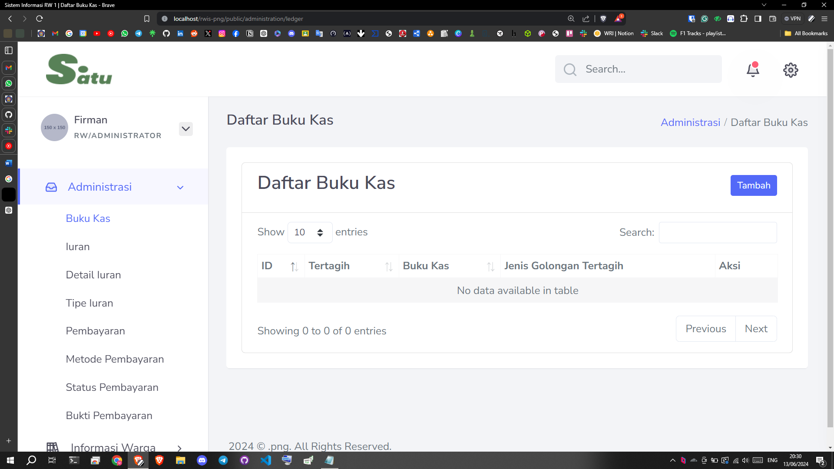

* + - * Contribution:

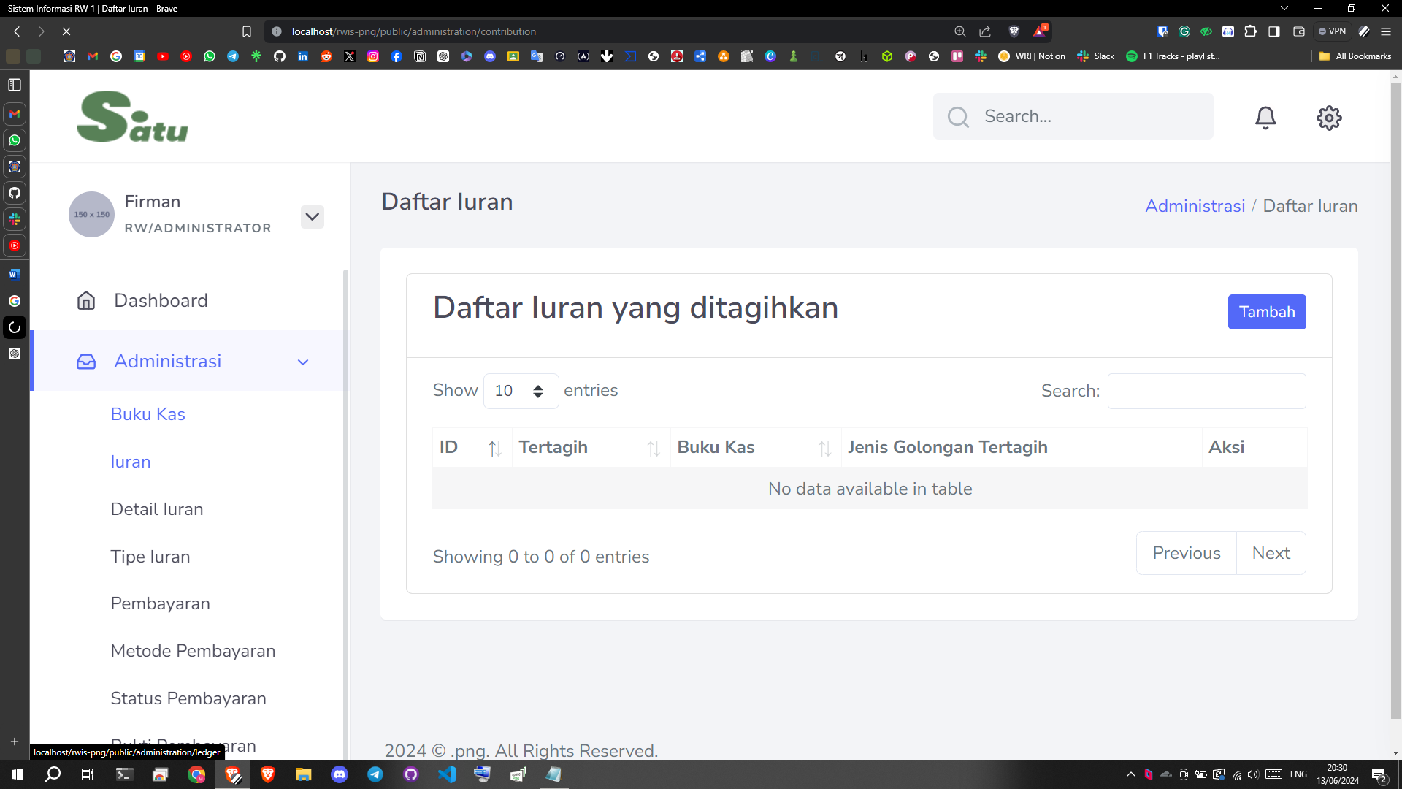

* + - * Contribution Detail:

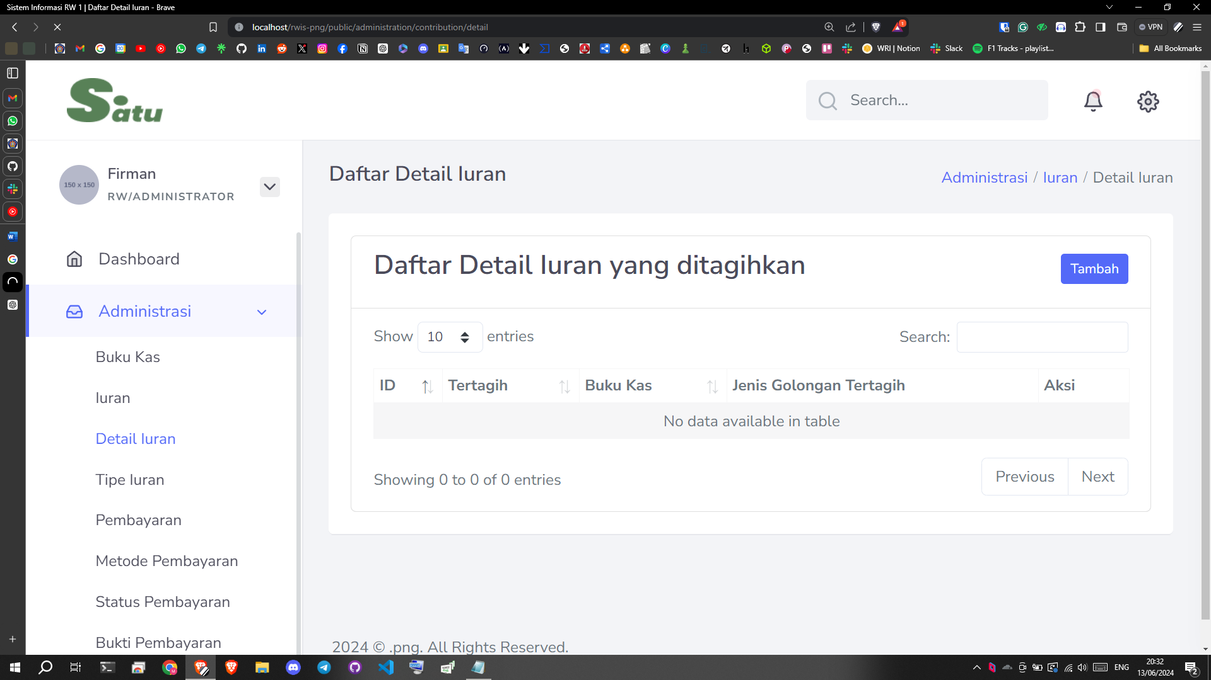

* + - * Contribution Type:

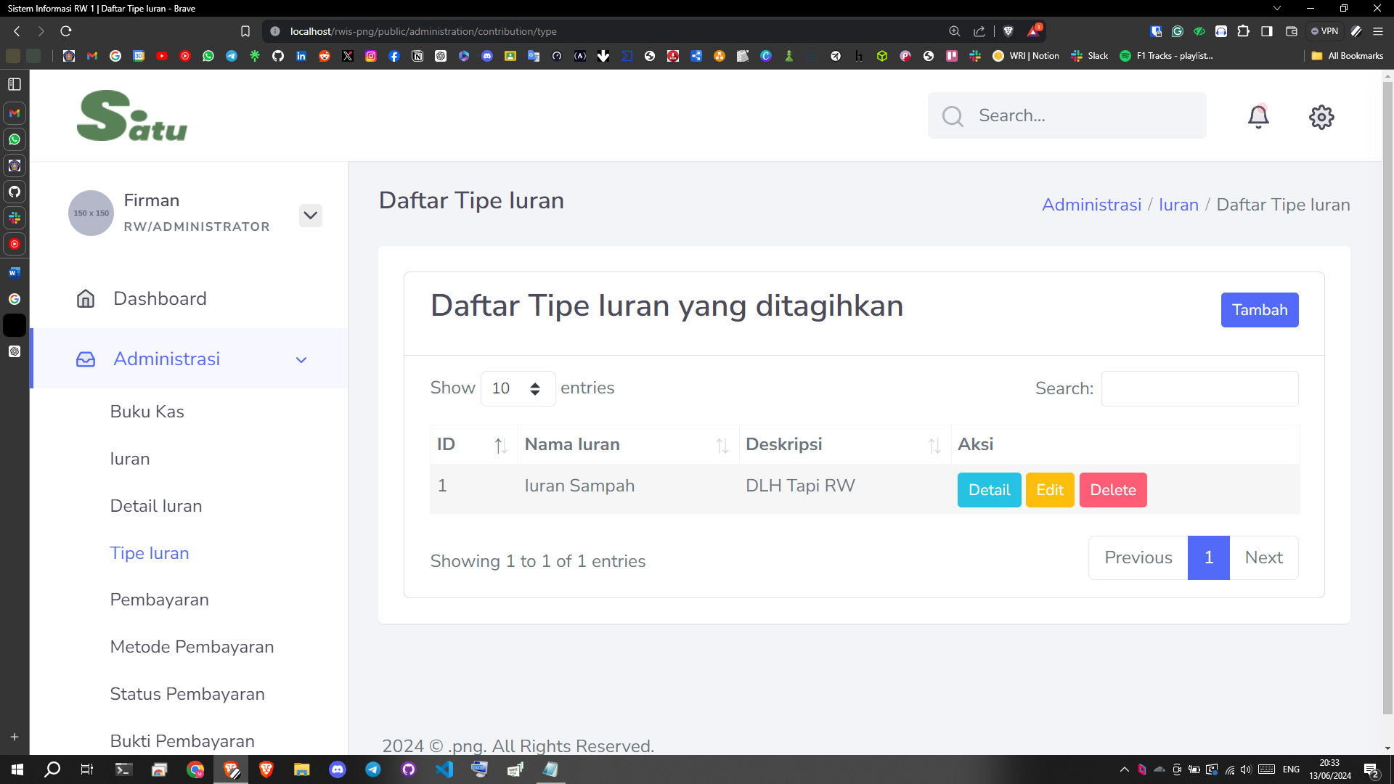

* + - * Payment:

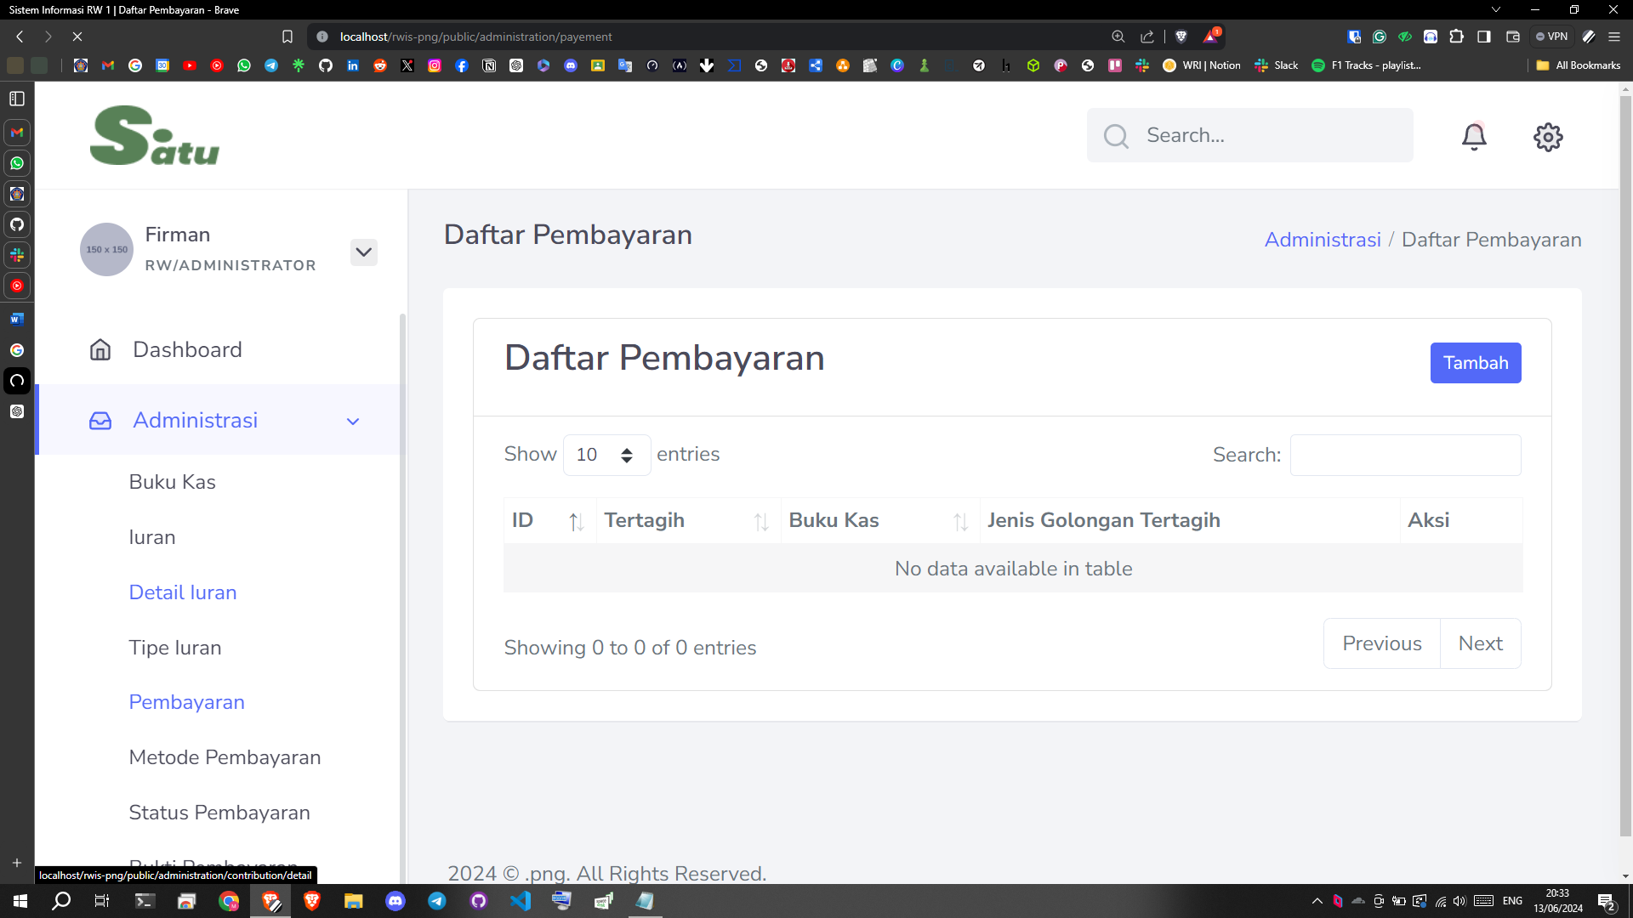

* + - * Payment Method:

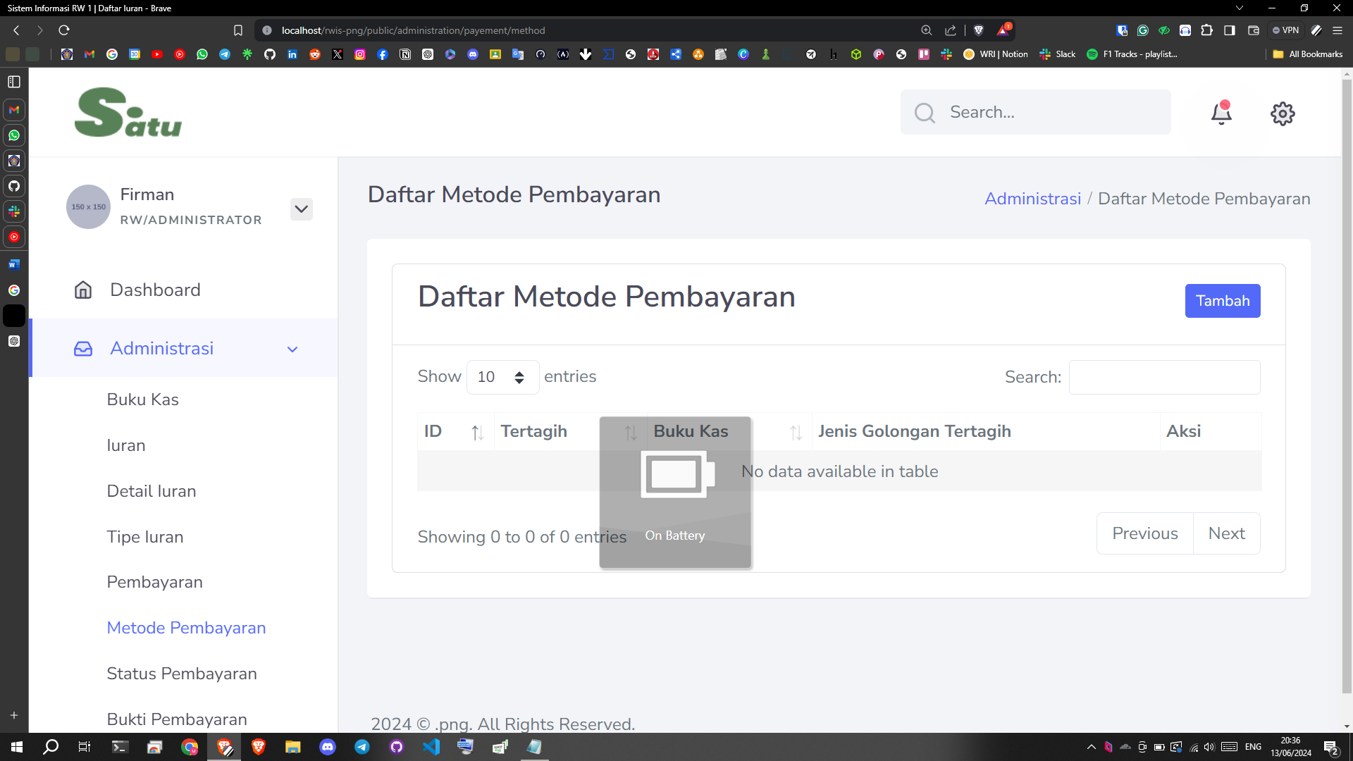

* + - * Payment Status:

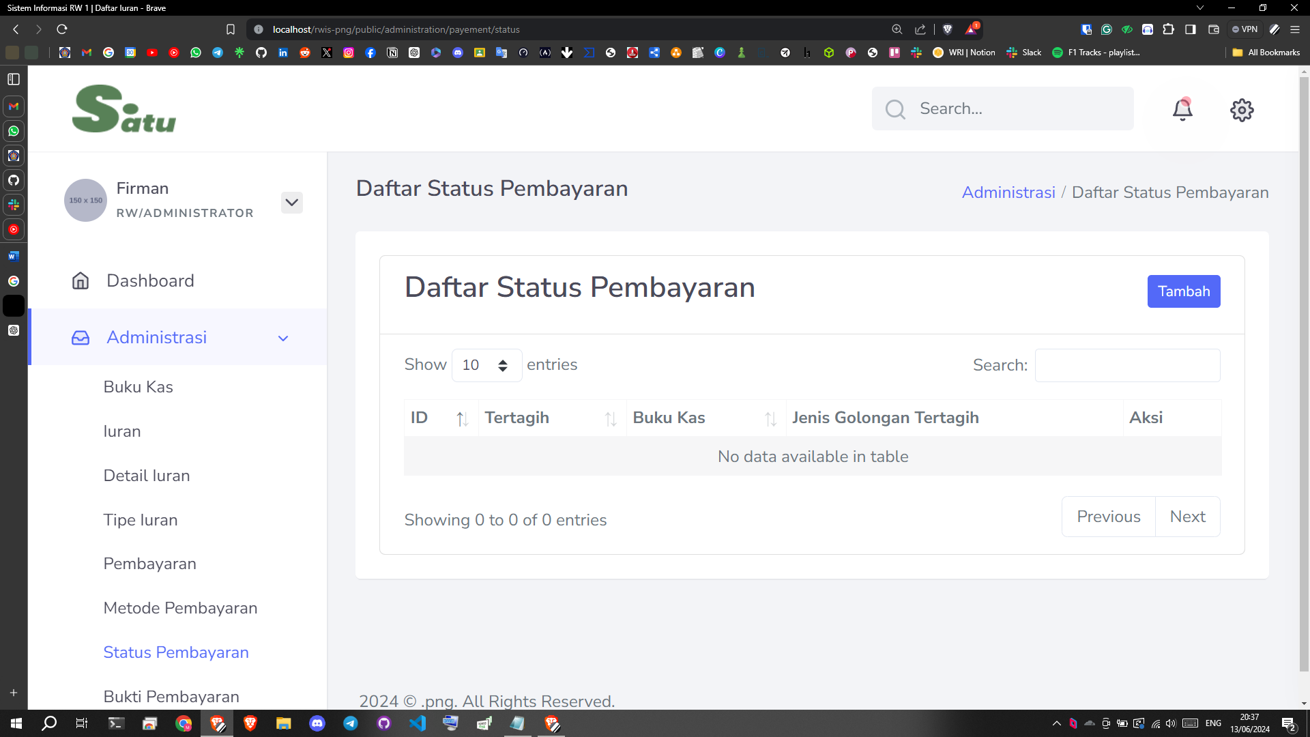

* + - * Payment Prove:

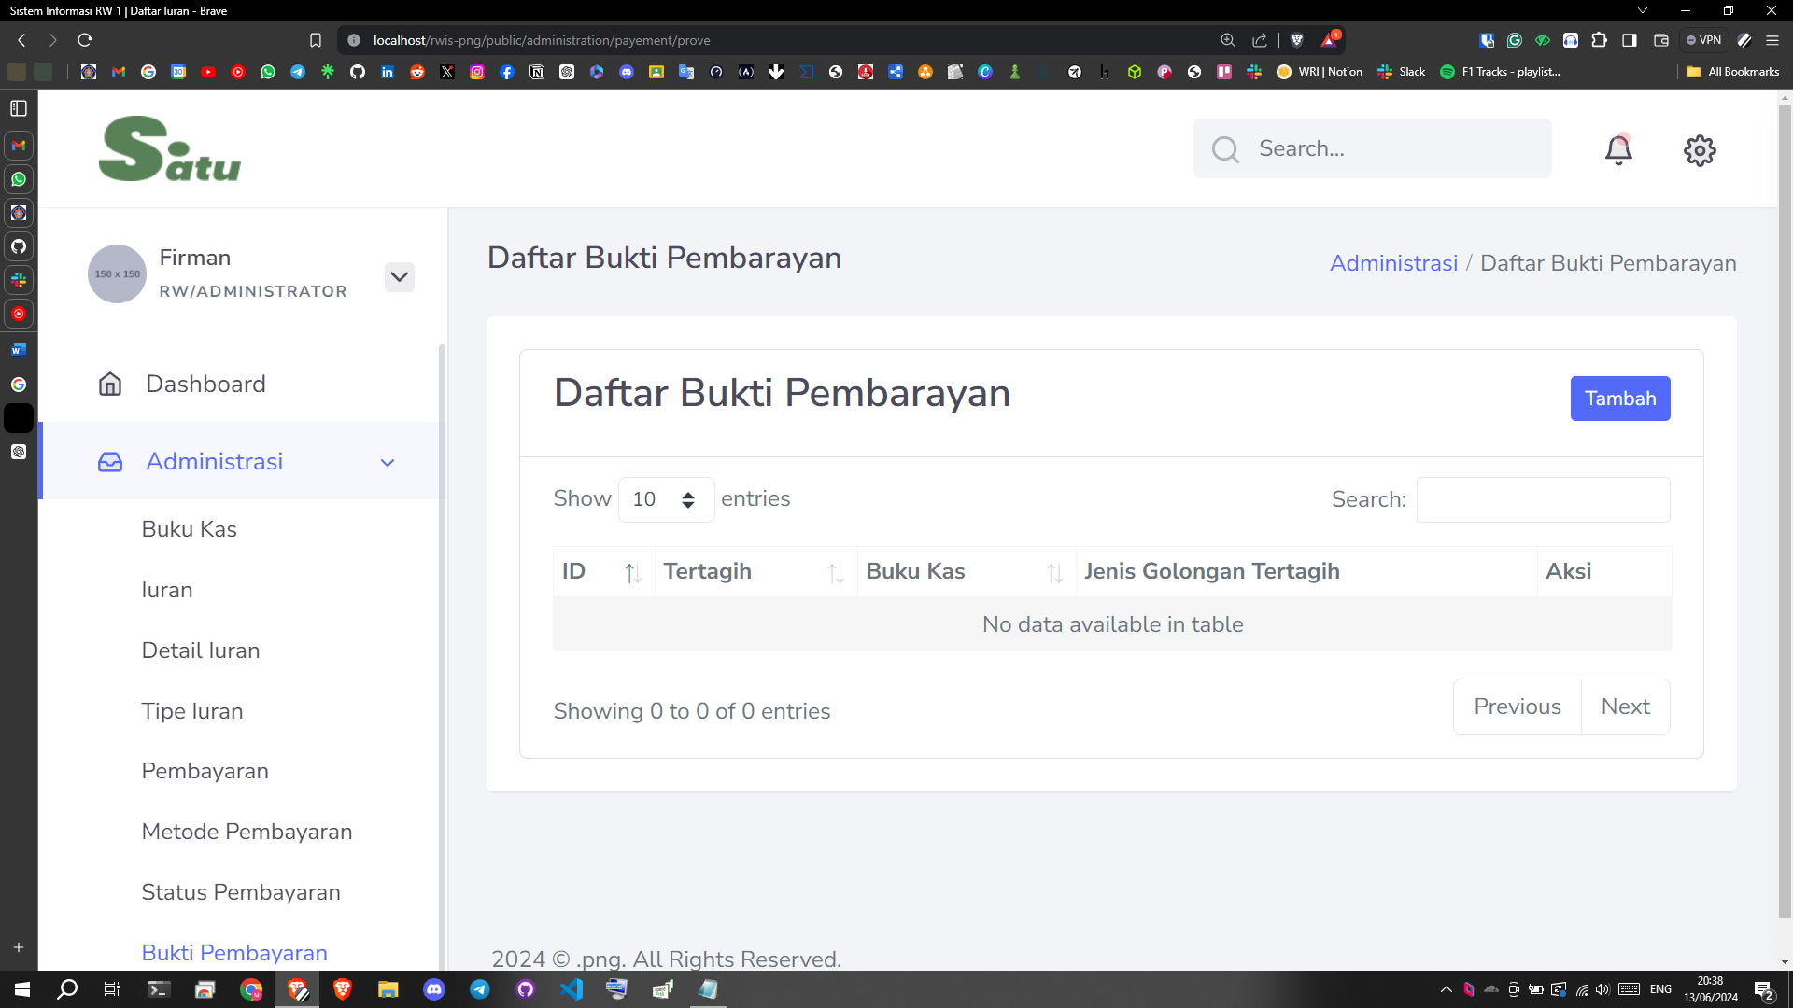

## Social Service

The social service domain was originally assigned to Malik Abdul Aziz. But due to the domain relation with the decision support system class, this domain is overtaken by Muhammad Baihaqi Aulia Asy’ari to be priority number one and accelerated the development. This feature was originally included with adding criteria, adjusting weight, storing the result to database, and deleting result. But due to lack of planning and time, the unnecessary feature has now been reduced to generating result with predetermined criteria and weight every time the page is loaded.

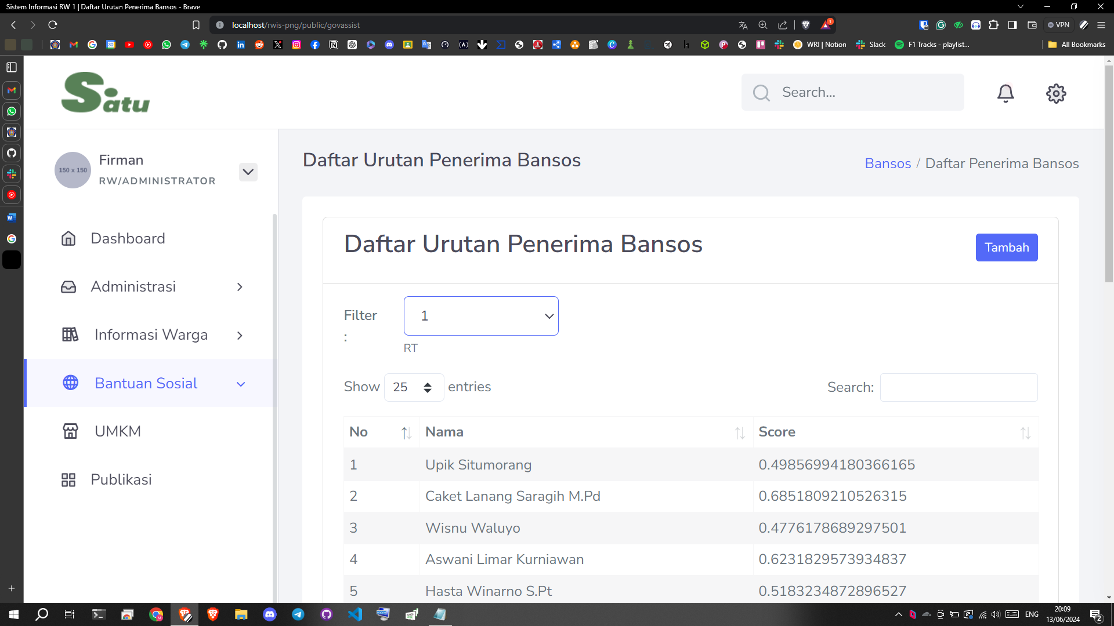

## Media/Publication

The media page was done by Hawa Esanda. The Citizen Activity Media Page is a platform designed to showcase various activities carried out by citizens in a community. This page is managed by admins, namely RT/RW and youth organizations, to share articles and photos about community activities, such as community service, community events, social activities, neighborhood meetings, and more. With this page, it is hoped that communication between residents can be better established and information about community activities can be spread more widely.

The main features of this publication page are:

* + - * Article

This section contains various articles that have been written by admins that only display image visualizations, titles, article predecessor sentences, and detail, edit, delete buttons.

* + - * Gallery photo

This section contains documentation of community activities that have been carried out. This documentation is expected to provide memories for residents who have participated in activities in the RT / RW environment. The documentation is in the article heading above the article title. However, I have not added the database to add images and still use hard code.

* + - * Form added data

Admin can add new articles or photos through this form. Supposedly, this form asks for information such as the title, author's name, description, date of the activity, and the photo file to be uploaded. However, due to a difference of opinion between me and one of the members, this was not done. In addition, the route is very incomprehensible.

* + - * Show data

Users can view the details of the articles that have been created and can save the uploaded photos.

* + - * Edited data

This feature allows users to edit existing articles or photos. Admins can update information that they have previously added.

* + - * Delete data

This feature allows users to delete articles that they no longer want. However, deleted articles do not disappear immediately, they will first be archived for 30 days after which they will disappear. This feature is also not working properly.

[SCREENSHOOT]

Finally, I would like to mention the obstacles that occurred from my point of view while working on this project. Many features did not work properly because the routes were too difficult and not easy to understand. Despite my inquiries, the route creator was unable to resolve the issue. In addition, the publication page was originally planned not to be combined with the umkm page, but when it came to the presentation day, there was a change of plan for the publication page to have an umkm menu. Therefore, the umkm menu could not be finalized.